Static Link / Dynamic Link / Dynamic Load

|  |  |  |  |  |
| --- | --- | --- | --- | --- |
| OS | Windows | Linux | Pros | Cons |
| **Static Link** | *.o | *.a | 速度快 | 占空間 |
| **Dynamic Link** | *.dll | *.so | 省空間 | 速度慢 |
| **Dynamic Load** | *.dll | *.so | 更省空間 | 速度更慢 |
| *Object File* | *.o | *.o |  |  |
| *Execute File* | *.exe | *. |  |  |

IMG:

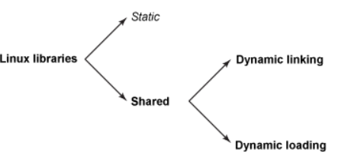

Put .so path:

export LD_LIBRARY_PATH=$LD_LIBRARY_PATH:/home/cyber/MP1/build

echo $LD_LIBRARY_PATH

Reference Link:s

<https://medium.com/@laura.derohan/compiling-c-files-with-gcc-step-by-step-8e78318052>

<https://phchiu.pixnet.net/blog/post/39869035-static-link-%26-dynamic-link-%26-load>

<http://puremonkey2010.blogspot.com/2011/04/linux-make-file-link-with-dynamic-and.html>